**Exoatmospheric Kill Vehicle**

From Wikipedia, the free encyclopedia

This article **needs additional citations for verification**. Please help improve this article by adding citations to reliable sources. Unsourced material may be challenged and removed.

*(February 2008)*

[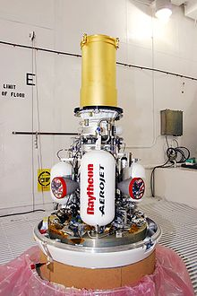](http://en.wikipedia.org/wiki/File:GMD_kill_vehicle_ift101.jpg)

Raytheon's Kill vehicle (EKV)

**Exoatmospheric Kill Vehicle (EKV)** can refer to two related missile defense concepts:

* *Most common:* the Raytheon-manufactured interceptor component with subcontractor Aerojet of the U.S. Ground-Based Midcourse Defense (GMD), part of the larger National Missile Defense system.
* Any exoatmospheric (outside the atmosphere) kinetic kill interceptor.

The Raytheon EKV is launched by the Ground Based Interceptor (GBI) missile, the launch vehicle of the Ground-based Midcourse Defense System. The EKV's own rockets and fuel are for corrections in the trajectory, not for further acceleration.

An EKV is boosted to an intercept trajectory by a boost vehicle (missile), where it separates from the boost vehicle and autonomously collides with an incoming warhead. EKV devices appear in both ground and ship based missile defense systems.

**Characteristics (of Raytheon's EKV)**

* Weight: approx. 140 lb (64 kg)
* Length: 55 in (4 ft. 7 in.) (1.4 m)
* Diameter: 24 in (2 ft.) (0.6 m)
* Speed of projectile: roughly 10 km/s (22,000 mph)[1]

**External links**

* http://www.raytheon.com/products/ekv/
* http://www.oss.goodrich.com/ExoatmosphericKillVehicle.shtml